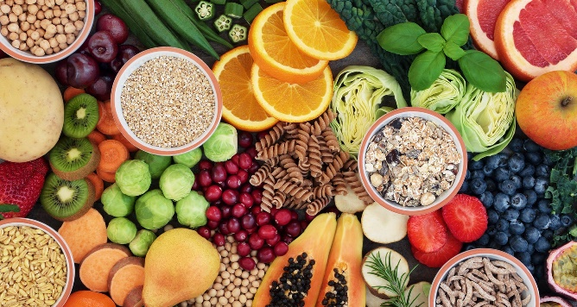**High School Lunch Menu**

**June 2nd-11th**

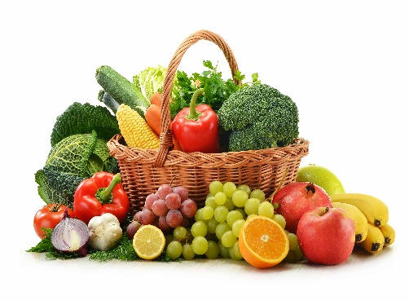

Monday, June 2nd

Egg & Cheese on a Croissant

Baked Apples

Tuesday, June 3rd

Taco Day

Wednesday, June 4th

Bacon Cheeseburger

Thursday, June 5th

Cheesesteak

Buffalo Chicken Cheesesteak

French Fries

Friday, June 6th

Pizza Party

Monday, Tuesday and Wednesday, June 9th, June 10th and 11th

Chef’s Choice

**All lunches are served with vegetables, fruit and milk**

**Menu subject to change**

Jennifer M. Mullin, SNS Washington TWP Food Service Manager 856-582-4010

Please look for the 2025-2026 SCHOOL MEAL AND S-EBT APPLICATION coming out soon, Have a great summer 2025!